GHLE - Greenland halibut survey East evaluation

Internal report, GINR, March 2021

J.Boje, F.Riget, S.Post, A.Noguiera & J.Nielsen

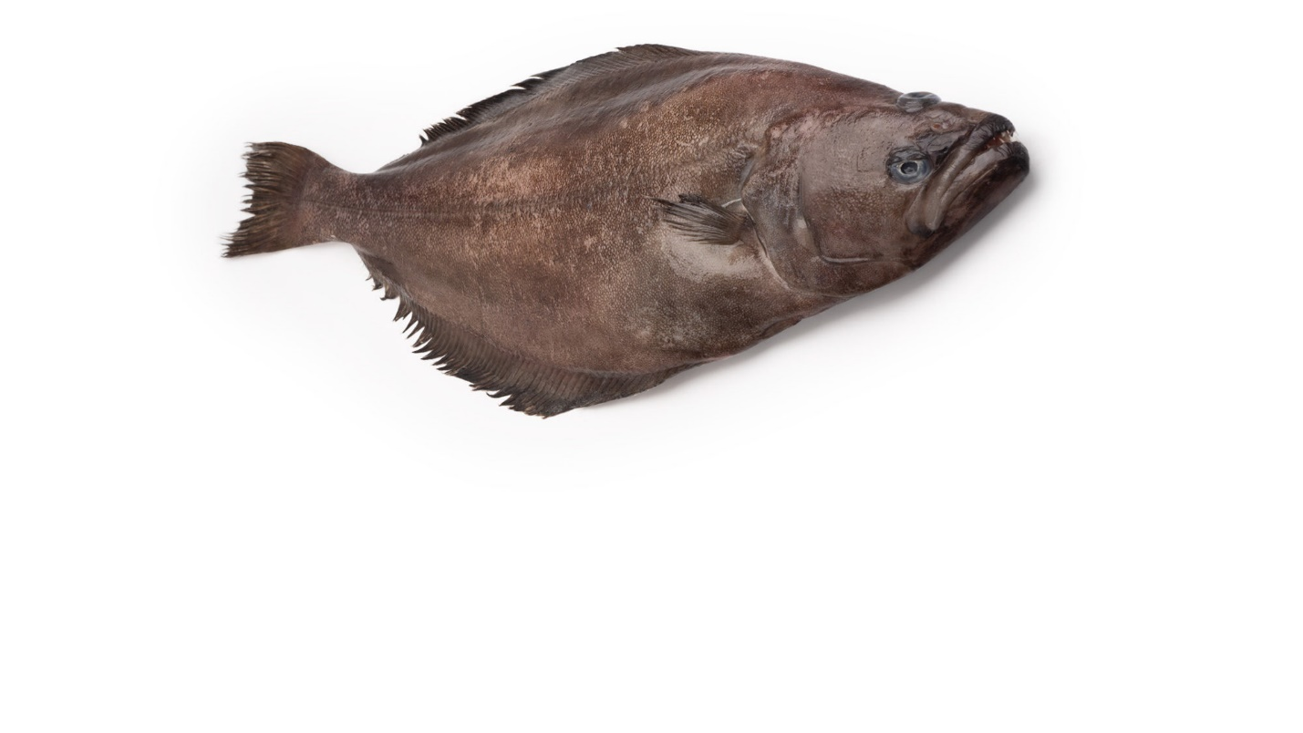

Contents

1. Background 3

2. Data and work platform 4

3. Evaluation of design and coverage 4

3.1. Problems associated with a random stratified design 4

3.2. Design of survey – season and day/night effect 5

3.3. Survey coverage 7

3.4. Survey stratification 7

4. Quality of the survey 8

5. Survey versus the fishery as biomass indicators 10

6. Indices from East Greenland versus Iceland 11

7. Use of survey output 12

8. Conclusions 12

**Appendix.** 14

1. Narrative 14

Minutes of meeting 11.12.20 14

Minutes of meeting 7.1.21 14

Minutes of meeting 15.1.21 15

Minutes of meeting 28.1.21 16

Minutes of meeting in GINR survey group 4.2.2021 16

## Background

The Greenland deep sea survey in East Greenland waters has been conducted since 1998 in order to monitor deep sea fish resources with the focus on Greenland halibut. The aim of the survey is to serve as biomass indicator for a stock assessment of the ghl stock in ICES divisions 5,6,12 and 14. The survey serves as one of more biomass time series in the analytical stock assessment. The assessment approach is a stock production model using annual catches, cpue’s from the Iceland fisheries and a combined survey index from Greenland and Iceland.

The East Greenland deep water survey began in 1998, was halted in 2001, and continued in 2002 to 2016. Since 2016 there has been no survey due to logistics/technical problems and in recent years due to lack of survey vessel. With the entrance of a new research vessel in 2021 the survey is scheduled to continue. With a new vessel and a new trawl gear implemented the time is for an evaluation of survey design and sampling protocol in relation to usage of survey in the assessment. At-sea calibration with the former vessel and gear is not an option.

Until 2016 the survey was conducted as a random stratified bottom trawl survey with the aim to estimate an absolute biomass based on the swept area and the area stratification. However, due to numerous skipped or moved hauls, and consequently large areas not surveyed (between 62 and 64 N lat) the stratification scheme was seldom met. Therefore, for use as a biomass index in the assessment model, the catch rates of Greenland halibut in the survey were standardised by year taken season, depth, and area into account to accommodate for the unbalanced design.

The present work therefore evaluates the survey design with respect to quality in relation to use in stock assessment considering a new vessel and a new trawl gear giving the opportunity to revise the survey design. The analyses will focus on internal variability in the survey and comparison of time trends to other available indices in the area such as cpue from the fishery and the Icelandic survey in the adjacent area.

On the fisheries CPUE in East Greenland (ICES Subarea 14) it should be noted: these are not utilized in the present analytical assessment. The reasoning behind this rejection is only based on conflicting trends between the East Greenland cpue and the remaining input series in the model, since the model cannot operate properly under such conditions. The rejection of this series is therefore only technical and not based on its quality to reflect biomass development in the area.

A major data flaw that prevents proper analysis of dynamics in survey and fisheries data is the lack of ageing. This prevents a disaggregation of data into ages/cohorts and does thus not allow to analyse for between year consistencies in year class abundance or consistencies between survey and the fisheries wrt year classes.

The aim of the present work is to

* Evaluate design and coverage i.e. random-stratified versus fixed station​
* Evaluate quality of survey, i.e. consistency between years​
* Evaluate output as use for biomass indicator, i.e. comparison with other indices in the area like fishery and Icelandic survey​

## Data and work platform

Data from the East Greenland deep sea survey, GHLE, 1998-2016 was uploaded on GINR, Teams platform ‘GHLE Team’ along with various R scripts for reading and analysing data. Also, logbook files from all fishing vessels in East Greenland 1998-2016 targeting Greenland halibut was made available at same site. Icelandic survey data was made available in order to make comparisons with the Greenland survey in the adjacent area in Iceland. Preliminary results and presentation draft was located on the team platform as well.

## Evaluation of design and coverage

### Problems associated with a random stratified design

A continental shelf and a steep slope between the shelf and the deep sea characterize East Greenland. Fishery for Greenland halibut is mainly on the slope at around 1000 m and often bottom is rough for trawling so fishing areas are often restricted and kept to known fishing grounds. The survey aims to cover both the adult fish area (fishing grounds) and shallower depth where immatures are distributed. The rough bottom conditions affect the survey efficacy and often causes long searching time for trawlable bottom and damaged trawl gear. This result either in a moved station position from the predefined position or a cancellation of the station. These events have a higher frequency in East Greenland than in West Greenland surveys. Fig. 1 shows that approximately 40% of planned stations in East Greenland 2010-2017 were associated with problem disclaimers in the dataset that has caused an exclusion from most subsequent analyses.

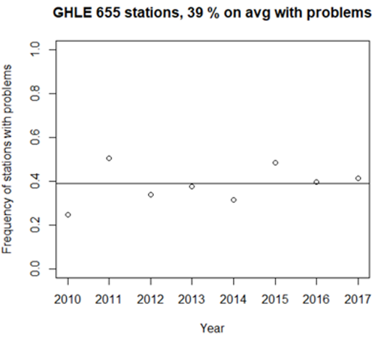

Fig. 1. Share of annual trawl stations 2010-2017 in East Greenland with ”problem” disclaimer (type 'B','b','D','K','k','U','Y‘) in GINR dataset.

The high number of stations associated with problems are time consuming. Both searching time when moving at station and damaged gear contributes to this. A fixed station design with known trawlable positions will increase efficacy, i.e., either allow same number of stations in a shorter survey period or allow more stations in a status quo survey period.

The relative high frequency of cancelled/moved stations could potentially deteriorate the principle in the random stratified sampling. This because often the station is moved to a nearby known trawlable position, e.g., a position that have been fished in recent years. This concern was analyzed by plotting how often a field code (GNs smallest statistical square) is sampled in consecutive years, in other words, are the well-known trawling positions (proxy is field code) fished more often due to difficulties in the planned positions from the random stratification. In the seven years of survey 60% of the field codes have only been fished once with no repetition the next year (Fig. 2) Around 35% of the field codes have been fished in two consecutive years in the seven years period and field codes being fishes four consecutive years or more are 20% and lower. This indicate that the present design works adequately​with respect to stratification.

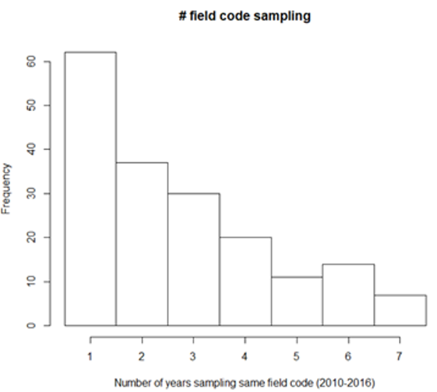

Fig. 2. Frequency of number of years a field code has been sampled in consecutive years.

### Design of survey – season and day/night effect

The design of the survey with respect to day/night operation was evaluated because many fish species have diurnal vertical feeding behaviour . The survey shifted from only day operations to night operation in 2008, and with no calibration hauls within the same year it is not possible to evaluate differences in catchability between day and night. Therefore, the effect of day/night on catchability for Greenland halibut was analysed by means of commercial logbook data. All vessels (nations) in the fishery for Greenland halibut was included from 1991-2019 filtering for targeted trawl fisheries for Greenland halibut. Aggregating cpue (kg/hr) per mid-hour over the day indicates higher cpue in daytime although variable over the day (Fig 3). Aggregating over day (6-18) and night (18-6) gives a factor of 1.03 higher cpue at daytime, e.g. 3% higher at daytime.

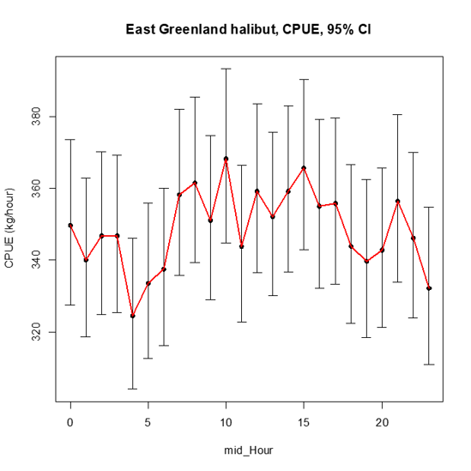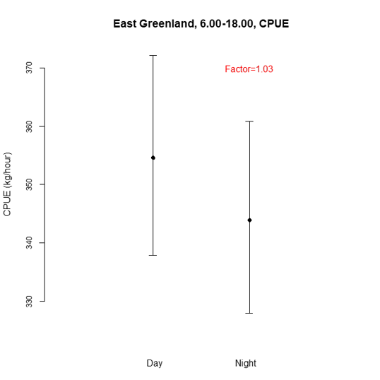

Fig. 3 Commercial fishery CPUE (kg/hr) aggregated by hour of the day (left) and day-time versus night-time (right). Taken account of the factors year, month, area and vessel effects (GLM).

Correspondingly, season effect was explored. The survey shifted from June/July to August/September in 2008 due to restricting ice conditions. An analysis of the commercial logbooks between these two periods revealed a difference of 7% between the two periods.

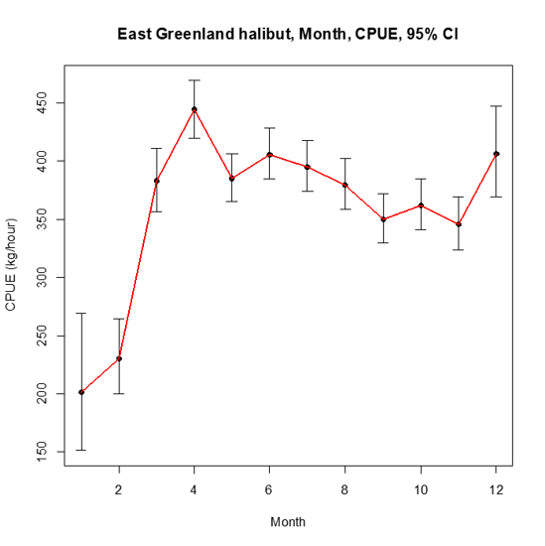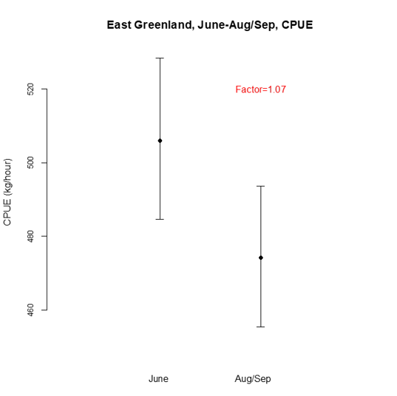

Fig. 4. Commercial fishery CPUE (kg/hr) aggregated month (left) and June versus August/September (right).

In summary, the change in hour of the day and season might have resulted in a cumulative effect of about 10% reduction in catch rates moving from June to Aug/sept and to nighttime. Therefore, catch rates in the survey database should be considered calibrated with this factor.

### Survey coverage

The survey is intended to cover most of the distribution of Greenland halibut in East Greenland but is restricted by duration of survey and steaming time between stations. As of now the survey covers GINR strata Q1-Q5 (61o45N-67oN) and depths 400-1500 m. Two strata (Q4 and Q6) are not part of the surveyed area due to known rough bottom, steep slope, and ice conditions. An Icelandic deep sea survey covers the Iceland EEZ and is utilized in the stock assessment in combination with the Greenland survey. The coverage is the Greenland and Iceland survey and the fishery distribution is provided in Fig 5. From the distributions it is obvious that the Greenland survey have large areas not surveyed but where fishery takes place. Further are more near shore areas that are surveyed but where no fishery is conducted. Catch composition in these areas should be scrutinized for low or zero catches. The near shore areas could be immature or juvenile areas and thus within the scope for the survey.

Independent of future stratification design, the surveyed area should reflect the fishery distribution more complete.

Fig. 5. Survey coverage in Greenland and Iceland EEZs (left) and distribution of the fishery for Greenland halibut (right), both from 2016. Depth contours are 500m and 1000m. A few outliers among the fisheries CPUE in the Irminger Sea are mis-placed positions.

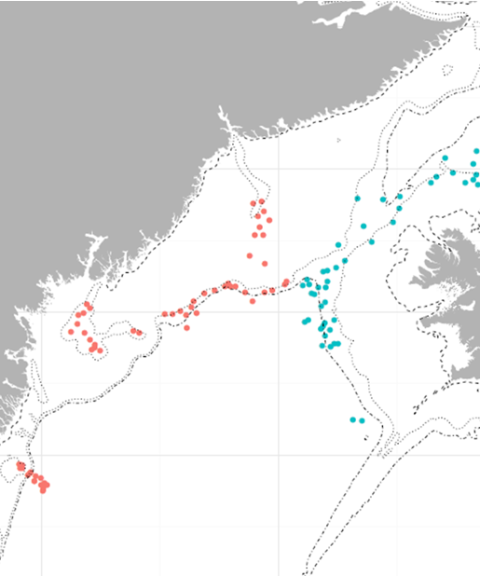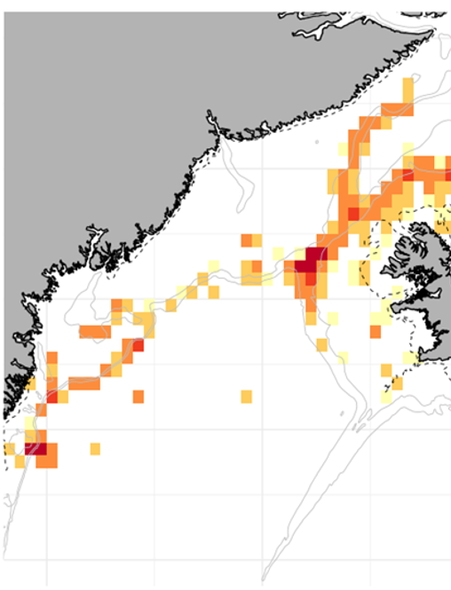

### Survey stratification

The survey has 5 area strata (Q1-Q5) but Q4 is not covered due to bottom condition. The number in depth strata among area strata with up to 5 depth strata in Q5 (401-600, 601-800, 801-1200, 1201-1400 and 1401-1500 m).

Fig 6 shows the standardized CPUE in logbooks data in the 5 depth strata after having taken year and month effect into account. No differences are found between depth strata 401-600 and 601-800 or between strata 1201-1400 and 1401-1600. Therefore, it should be considered to reduce numbers of depths strata to include only the three depth ranges 401-800, 801-1400 and 1401-1600. This would allow to expand the survey area or increase the number of stations by strata.



Fig. 6. Standardised CPUE from the fishery for Greenland halibut by depth range.

## Quality of the survey

There are more ways to express the quality of a survey; sampling variability expressed as annual CVs and ability to track cohorts between years are the two issues in focus here.

The precision of the survey catches measured as CV of the biomass for the surveys is generally poor with CVs between 50% and 150% (Fig. 7) and seem to be increasing in the last years of the survey. Coverage was poor in some of these later years so that might explain the high recent CVs. However, generally the variability is high in the survey.

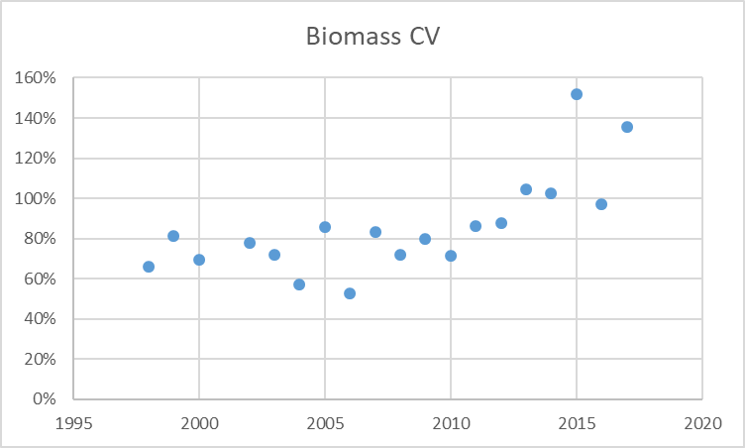

Fig. 7. CVs of the estimated biomass from the GHLE surveys 1998-2017.

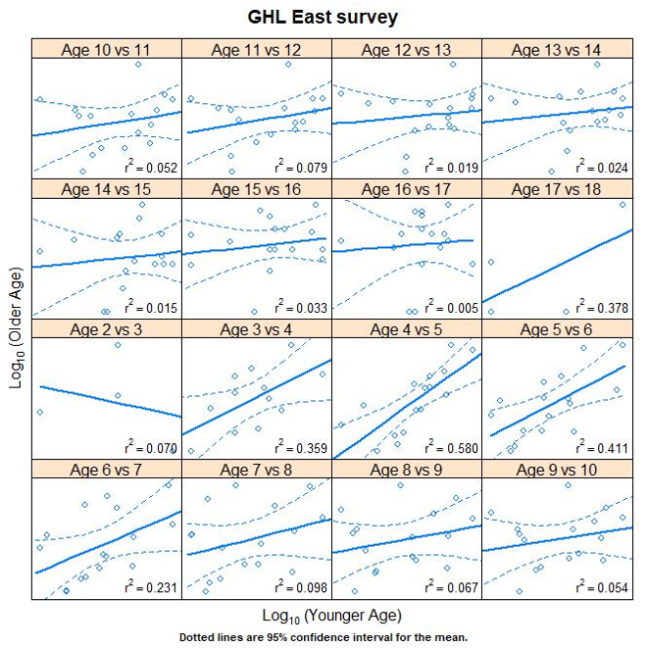Another measure for survey quality is the ability to track year-classes from one year to the next, e.g. to follow cohorts contributing to robust population distributions. Since no ageing is conducted for GHL in GINR, an Icelandic ALK from the Icelandic survey for the years 2017-2020 was a potential use for the East Greenland survey. The assumption is similar growth rates as in Iceland and contact growth between years for the entire survey period. The Iceland ALK was applied to the survey catch compositions and regression were made between age groups in consecutive years (Fig. 8), a so-called consistency plot. The plots show that in general the survey is not able to track year-class strength from one year to the next. The coefficient of determination (R2) is only more than 0.5 for the regression age 4 vs 5 while the remaining relations are weak.

Fig. 8. Consistency plot for the Greenland survey using Iceland ALK. Age at year a is plotted against age at year a+1.

Another way of displaying cohort tracking is by standardised index of age per year-class (Fig 9). This gives information of how uniformly year-classes are estimated at each age in its life span. Fig 9 shows that for most year-classes there is a wide range in estimation of the strength for different ages from that year-class. In example, the 2000 yc is nearly estimated record high at age 4, while reaching age 10 the same yc is estimated very low. At all other ages this yc is estimated in between these two extremes. This illustrates the poor ability of the survey to precisely track the strength of a year-class.

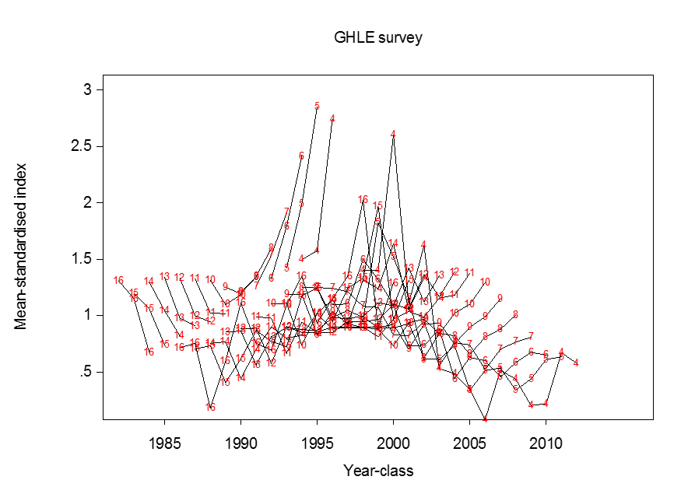

Fig. 9. Standardised index of ages versus year-class. Each line is an age group and red numbers indicate age.

The poor internal consistency of the survey might have several causes; it could be due to distribution of the Greenland halibut age groups, i.e. are all age groups available in the entire survey area at the survey time? The surveyed area or season might not be representative for the entire stock.

## Survey versus the fishery as biomass indicators

Both survey and fishery catch data are input to the stock assessment as biomass indices. The relation between CPUE from the fishery and catch rates from the survey was therefore evaluated. Haul by haul logbook data from all fishery incl. international fishery with bottom trawl for Greenland halibut were used. The fisheries data was filtered according to survey season, i.e. the season window June in the years 1998-2008 and August/September in 2009-2017. To allow a geographical comparison data was aggregated by ICES rectangle (30' N, 1°W intervals) with at least 3 observations (Fig. 10). Although significant the relation between catch rates in the fishery and the survey is not strong. The comparison was also done by survey strata, however, the same picture was evident – no strong relation. There might be several reasons for this; gear selectivity is the most likely since the commercial fishing gear have larger mesh size and therefore catch less smaller fish than the survey. Haul speed is another factor that can have contributed to the poor correlation, since fishing vessels trawl at about 5 knots while the survey have hauling speed of 3-4 knots. Larger Greenland halibut are known to be able to escape slow speed trawl hauls. These two issues might together contribute to a large difference in selection between survey and fishery performance. In order to eliminate the selective issue from the comparison analyses, we made an attempt to dis-aggregate all catches into age groups for comparison. The Icelandic fixed ALK was assumed representative for both fishery and survey.

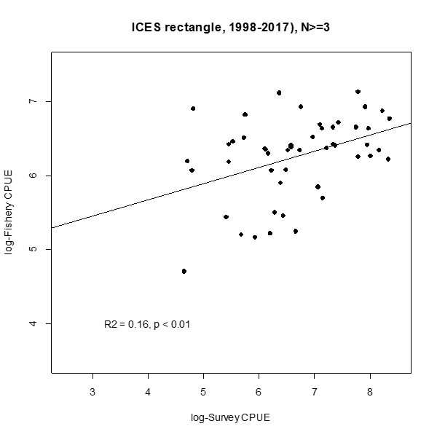

Fig. 10. Plot and linear regression of log-survey catch rate versus log-fishery cpue within ICES rectangels. R-square and p is shown for the regression.

The internal consistency from the fishery derived from using the Iceland ALK is shown in Fig. 11 (left). Tracking year-classes is very poor for the fishery and in many cases the relationship is inverse. Therefore it is neither expected that the survey and the fishery should correspond with respect to measurement of year-class strength (Fig 11 right). The external relationship between the two data sets only has an r-square higher than 0.5 for age 5.

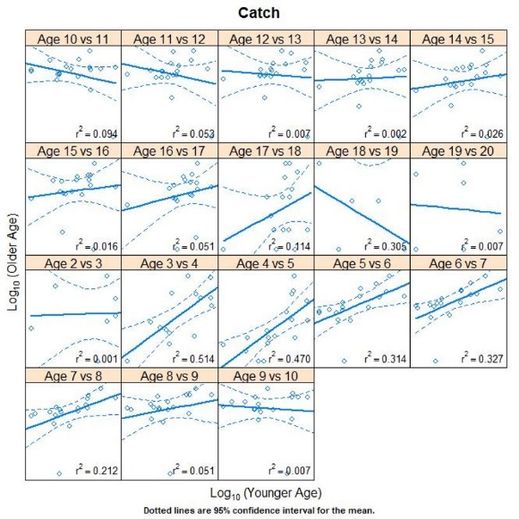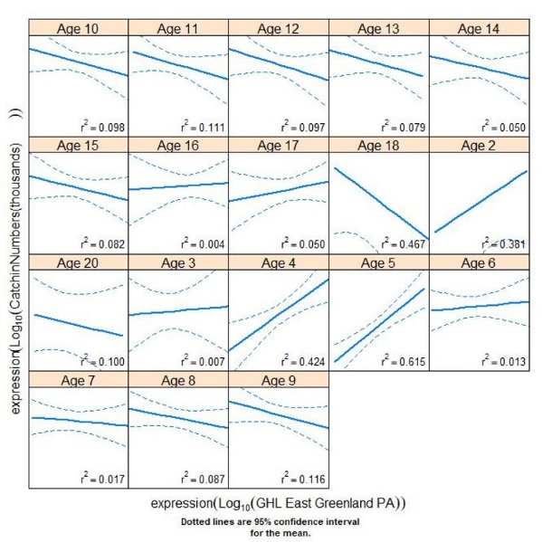

Fig. 11. Left: Internal consistency in catches from the commercial fishery. Right: External consistency between the fishery (x-axis) and the Greenland survey (y-axis).

## Indices from East Greenland versus Iceland

The part of the East Greenland survey east of 33000 W (closest to the border to Iceland) and the part of Icelandic survey with latitude higher than 65030 N and longitude higher than 18000 W (closest to the border to East Greenland) were selected for comparison of indices. Mean weight of specimens in surveys is considered a proxy for catch composition and yc contribution. Generally, the mean length of the fish over the time range 1998-2016 has the same trend and is also within the same length range (Fig. 11).

*External consistency between Greenland survey versus the Iceland survey are awaiting in this section*.



Fig 11. Mean length of Greenland halibut caught in selected neighboring areas of the East Greenland survey and the Iceland survey

## Use of survey output

In the present model the index from the Greenland survey is considered a biomass index value and thus not an absolute value of biomass or abundance. However, with the resuming of the GINR age reading of otoliths an age-disaggregation of both survey and fishery data is foreseen and will soon be input to the assessment. This will allow for age-based stock assessment models like Gadget, SAM or simpler deterministic VPA-type models.

For any of these models the survey catches will still be treated as biomass index values, which is important to consider when deciding on the survey stratification design. A random stratified design will allow to estimate absolute values of biomass and abundance while the fixed station design will not allow that but only estimate relative indices comparable between years.

## Conclusions

The Greenland deep sea survey for Greenland halibut in East Greenland is a prerequisite for fishery-independent data to stock assessment of the Greenland halibut population in the area. The survey started in 1998 and conducted until 2017. Since then, no survey has taken place in the area mainly due to lack of research vessel. With the entrance of the new Greenland research vessel TARAJOQ in 2021 the survey is foreseen to resume annually.

The present analyses and considerations have visualized a number of issues to consider for the future survey design and sampling procedure for the TARAJOQ deep sea survey. These are

* A fixed station survey design will allow more hauls due to less searching for trawlable bottom (than random-stratified design) and thereby more data points from the area or an extended area surveyed
* A fixed design will provide annual index values as required in present and future stock assessment models
* A fixed design will generally provide more accurate temporal trend but may be biased compared to a random design, which are more uncertain but with an unbiased estimate (Warren, 1994).
* A random-stratified survey design will provide an output that will enable to analyse for spatial distribution patterns over the years – a valuable product when considering climate change evaluation a.o.
* Due to change in season and day/night operation, it is suggested that historic time-series are calibrated for this according the present estimated factors.
* Survey area coverage is suggested to be changed to at least cover the commercial fishing grounds; an expansion of coverage should be done in one year, where after the new areas can be considered in the index estimation after approx. 5 yrs or when an appropriate time series has been established.
* It should be considered not to cover the inshore area where no fishery is taken place or to examine whether these shallow areas contribute to estimation of young fish.
* It should be considered to reduce number of depth strata to include only the three depth ranges 401-800, 801-1400 and 1401-1600. This would allow to expand the survey area or increase the number of stations by strata.
* A scrutinizing of how to improve the precision of the survey estimates (CV) and the internal consistency should be initiated. Presently no clear solutions have appeared.
* The survey and fishery catch trends between East Greenland and western Icelandic waters should be further analysed along with newly arrived information on stock ID. This knowledge should be implemented in stock assessment and catch advice.

# **Appendix.**

## Narrative

### Minutes of meeting 11.12.20

Deltagere: Nanette, Søren, Julius, Frank, Jesper (ref).

Dette var første møde omkring analyse af survey design/protokol for hellefisk ved Østgrønland.

Baggrund:

Surveyet bruges som input til bestandsvurdering af hellefisk ved Østgrønland, Island og Færøerne. Survey’et har været stoppet siden 2016 pga teknik/manglende skib. Ved genoptagelse af survey i 2021 med nyt skib og ny type bundtrawl er der derfor behov for en vurdering af survey design og indsamlingsprotokol.

Biomasseindeks estimeret ud fra den nuværende stratifikation har ikke været anvendt som input til bestandsvurdering siden 2012? pga af den ubalancerede dækning (is og bundforhold har forhindret træk i et stort område mellem 62 og 64N). Derfor bør den nuværende stratifikation re-evalueres mhp både dækning, catchabiliy i nyt redskab og mht kombinering med islandsk survey.

Besluttede tiltag

Tidligere indlæsningsprogrammer/scripts findes ved GN og der laves et udtræk fra ACCESS af alle survey øst data til en csv fil som vi kan arbejde på. Gode programstumper til beskrivende analyser deles.

1. Julius sender indlæsning programmer og data (csv filer) til survey
2. Nanette opretter sharepoint eller lign sted at samle dokumenter/data om surveyevaluering
3. Findes spredte ctd/starmon data? Nanette?
4. Potentielle analyser: effekter af variable (dybde, område, dag/nat, træktid, temperatur, måned(juni/okt) etc.
5. Et fixed station design er en oplagt mulighed med de årlige vanskeligheder med at finde trawlbar bund.

### Minutes of meeting 7.1.21

Present: Jesper, Søren, Frank, Julius

1. Teams sharepoint site is established and used for documents, data and scripts in R. It works well. All survey data are available as csv files as well as fishery data (logbooks) and Iceland survey data.
2. Frank has conducted a number of analyses as follows (filename HellefiskØst.pptx in exploratory analysis folder):
   1. There is a day-night effect on survey catch rates being highest during daytime – however this only account for about 3% difference
   2. Cpue data from the fishery suggest a season effect cpue being lowest in autumn (when survey is carried out).The difference between cpue in June and August – September is about 7%.
      1. Consequently, adding the season and day-night effect as shown for survey and fishery, could result in a factor of 10% to correct for change in survey season and time at day hauling (survey time changed in 2008 from June to August/September).
   3. The quality of the survey wrt CV is not impressing; analyses were done by stratum and depth interval and was generally high, 50-100%. Normally as survey is considered appropriate when cv is in the neighbourhood of 20-30%.
   4. A comparison of survey catch rates was done with fishery cpue by stratum and depth. Not considering season there is no correlation between the two series. Considering season, June and Aug/Sept (split in 2008) with observations in cells higher than 3 gave a positive correlation though not significant (R2=0.16, p=0.01). This means that the present deviance in survey time trends and fishery cpue is most likely due to a season effect.
3. Based on these findings it was decided to:
   1. Further scrutinize the survey data; especially the quality note for each haul evaluating validity of haul. Rather many hauls are semi-disqualified (station moved due to bottom conditions or short hauls due to the same, etc). A fixed station design will improve the efficiency of the survey (more hauls) and thus improve quality. A quantification/tabulation of category B validity hauls is required to evaluate this fully.
   2. In absence of age-based data, length data from the survey could be used for analysing year to year consistency and also between fleet consistency (survey versus fishery). Length data from the fishery will be collated and also data from the Iceland survey will be made available in order to compare overall catch rates in neighboring areas (each side of the midline between Greenland and Iceland) as well as length data comparison.

### Minutes of meeting 15.1.21

Present: Jesper, Søren, Frank, Adriana

**On pt 3a** from previous meeting 7.1.21; Søren will tabulate survey haul numbers by year and field code in order to illustrate the basis for a future fixed station design.

Follow-up on this: Søren made plots of numbers of stations discarded or moved and plot of GN field codes hauled/sampled repeatedly over the seven years (doc name “analysis of time problems in GHLE.doc”). 39% of stations had problems (either removed or discarded) on average. However, more than half of all station have only been trawled either 1 or 2 times over the last seven years. This indicates that a ‘fixed-station regime’ is not yet the case. This could be considered due to that randomly chosen stations not possible to haul be moved to previous hauled station.

Frank updated the correlation plot of catch rates between survey and fishery; all fisheries is now included, i.e. foreign vessels and Greenland vessels. It is now split in season (before and after 2008 when survey shifted). When data is split by stratum and depth the correlation is relatively good (not significant) for the southernmost strata (Q2 and Q3) with most data, but not for the remaining northerly strata.

Comparing survey and fisheries within ICES rectangles for all data, still by season (before and after 2008) and with observations more than 3 the correlation fits well (r2=0.16, p<0.01).

**On pt 3b** from last meeting; it was decided that Icelandic ALK could just as well be used for a real age aggregation of surveycatches instead of length based assumptions on age classes. A total ALK for more years in Iceland is considered robust assuming no inter annual growth differences.

### Minutes of meeting 28.1.21

Present: Frank, Søren, Adriana, Jesper

Based on annual length distributions from the Greenland survey and application of the Icelandic ALK, annual age distributions were made for the GHLE survey. However, it was recognised that the basis for the length distributions was relative numbers by year and not weighed by stratum area, so this needs recalculation before we can present age distributions that can be utilized for cohort strength comparison between years. Frank agreed to recalculate length and age distributions.

The assumptions made for the use of the Icelandic ALK is that growth is assumed constant between years and area. The data are therefore pooled for all in Icelandic data (2015-2019). Iceland has resumed ageing of GHL recently and so far read 2015-2019 otoliths.

It was agreed to present our results and progress for the survey group at GINR February 4. Jesper will make a first draft ppt.

### Minutes of meeting in GINR survey group 4.2.2021

Present: Tanja, Helle, Frank, Søren, Adriana, Rasmus, AnnDorte, …more ?

Jesper presented the work from the evaluation group. Based on this presentation a number of issues was discussed.

1. Survey design discussion:

One issue was some concern on the comparability with the West GHL survey. However, the two surveys monitor separate stocks, thus the results of the two surveys are not used either for comparison or for combination. Therefore, it was agreed that same survey designs are not a prerequisite considering their purpose.

The issue of shifting to a fixed design survey: The issue have been raised because on average 40% of the annual intended station have either been cancelled, removed or otherwise indicated with problems. This has caused high variation from year to year in intended coverage and consequently the survey catch rates have been standardised by use of a GLM to accommodate for the unbalanced data, thereby not utilizing the advances of a random-stratified survey. There are pros and cons in relation to fixed station design versus random-stratified survey as follows:

**Random-stratified design**

PROS

* The output provides a use for spatial analyses of the distribution of caught species
* The output relates to absolute numbers and biomass; this can be utilized in advice/management if a target exploitation rate is recommended

CONS

* The random distribution of stations causes many cancellations because of the rough bottom in East Greenland (southeast has a very steep continental slope).
* The many cancellations means that fewer stations than intended are conducted due to search time for new locations.
* The present output as absolute numbers and biomass for the entire area is not used for assessment purposes because of too unbalanced design (too many cancelled stations).

**Fixed station design**

PROS

* Known trawlable locations means an optimization of effort with no search time. Number of station could therefore be increased compared to present design (higher precision/lower CV?)
* The output is directly suited stock assessment input as relative abundance and biomass
* Improved enthusiasm among crew with lesser ‘quite’ periods

CONS

* The output provides only a use for temporal analyses of the caught species, ie. time scale analyses.
* If stock connectivity to southwest Greenland offshore will become an issue the two surveys are more difficult to compare (but not impossible).

It was decided that some kind of external review/comments is required for this important decision. Adriana will contact Canadian experts and Jesper will take contact to Kai Wieland at DTU Aqua. Further, if a change to a fixed design is decided, the procedure of future station location need to be outlined. Information on historic haul positions should be used in this context.

1. Survey coverage discussion

There are discrepancies between fisheries distribution and survey area. Near shore stations in present survey are outside fishing areas and the other way round, a vast area between 64 and 65N and the area north of 67N is not surveyed but regularly fished in the past 10 years. Independent of choice of survey design the inclusion of the two new areas should be considered. Similarly, the exclusion of the near shore areas at 65N and 67N should be considered.

It was noted that survey should not necessarily cover entire fishery distribution, but rather total stock distribution.

1. Survey quality discussion

The survey generally have high CVs on the abundance estimation, for strata it ranges from near zero to 150%. Søren conducted a new overall CV estimation by year (after the meeting) and it reveals CVs in the range 53-152% for biomass estimates and 62-152% for abundance estimates. This is considered a far too low precision; rule of thumb is max 30% for surveys. Examination of the script is required and the issue needs further scrutinization especially considering the upcoming benchmark in 2022.

An application of Icelandic ALK (2016-2019) to the survey catch distributions made is possible to construct catch at age for the survey assuming no change in growth for all survey years (same ALK used). Year-class consistency analyses of the survey showed a relatively poor consistency; the survey did not track the cohorts from one year to the next properly. However, this needs further examination and also the application of Greenland ALK.

The meeting closed with a decision to resume after 1) more exploratory work on comparison between Iceland and Greenland survey catch rates and 2) awaiting external comments on design.